**4. Use Cisco packet tracer for the below:**

**5. Set up trunk ports between switches and try ping between different VLANs.**

**Steps Followed:**

* Placed two switches and PCs.
* Connected them with cables.
* Created VLAN 10 and VLAN 20 on both switches.
* Assigned PCs to VLANs.
* Configured a trunk link between switches.
* Assigned IP addresses to PCs.
* Tested connectivity (same VLAN OK, different VLANs failed).

**Setting Up:**

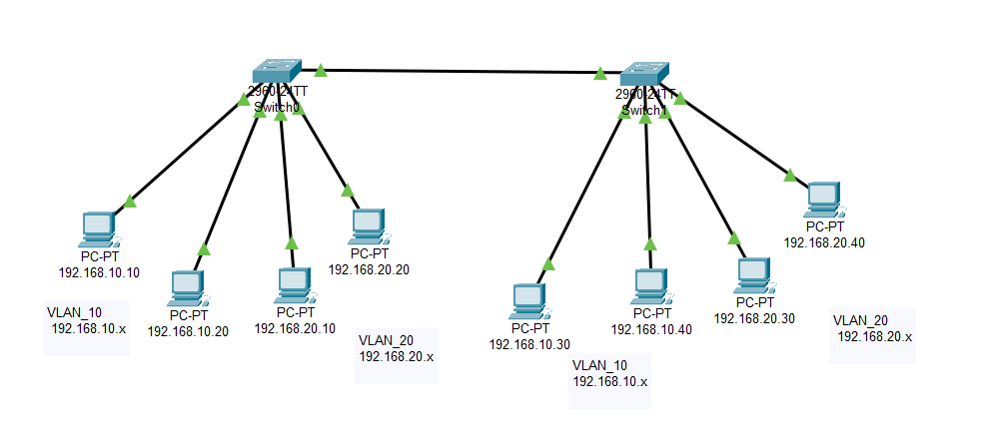

**Pinging 192.168.10.30 (2nd Switch – Vlan_10) from 192.168.10.10 (1st Switch – Vlan_10): Success**

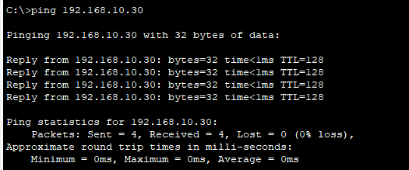

**Pinging 192.168.20.10 (1nd Switch – Vlan_20) from 192.168.10.10 (1st Switch – Vlan_10):**

**Ping Fails**

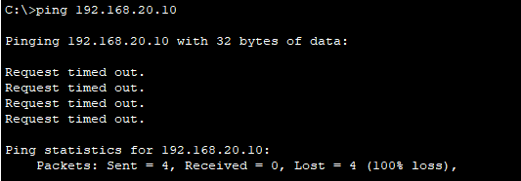

**Ping Fail reason - we have not configured any routing.**